**Design Document**

**For**

**Guest House Booking in NITC**

Version 1.0

Prepared by Team **13**:

(Based on SRS Version 1.0)

|  |  |
| --- | --- |
| **Palash Bajpai** | **B180759CS** |
| **Aditya Jha** | **B180648CS** |
| **Atul Singh** | **B180738CS** |
| **Amit Kumar Panja** | **B180887CS** |
| **Ritik Gautam** | **B180630CS** |

## 

|  |  |
| --- | --- |
|  |  |
| **Course:** | CS3004D Software Engineering |
| **Date:** | 8 April 2021 |

# 

# Glossary

|  |  |
| --- | --- |
| Admin | One who have all access to the application. He will be able to see database of application and other features. |
| Client | One who request for the application to be made. This case it is NITC guest house management staff. |
| User | One who interact with the application. |

## **Table of contents**

**Glossary** **2**

**Table of contents** **3**

**Detailed Design through UML diagrams** **4**

1.1 System model using Class Diagram 4

1.1.1 Class Diagram 4

1.2 Responsibilities - Usecase Diagram 4

1.3 Static snapshot of the system - Object Diagram 4

1.4 System Interactions through Sequence Diagrams 5

1.4.1 <Name of Sequence Diagram 1> - <Team member Name> 5

1.4.2 <Name of Sequence Diagram 2> - <Team member Name> 5

1.4.3 <Name of Sequence Diagram 3> - <Team member Name> 5

1.4.4 <Name of Sequence Diagram 4> - <Team member Name> 5

1.4.5 <Name of Sequence Diagram 5> - <Team member Name> 5

1.5 Control and Data Flows through Activity Diagrams 6

1.5.1 <Name of Activity Diagram 1> - <Team member Name> 6

1.5.2 <Name of Activity Diagram 2> - <Team member Name> 6

1.5.3 <Name of Activity Diagram 3> - <Team member Name> 6

1.5.4 <Name of Activity Diagram 4> - <Team member Name> 6

1.5.5 <Name of Activity Diagram 5> - <Team member Name> 6

**Database Design** **7**

2.1 ER Diagram 7

**Implementation Plans** **7**

3.1 Technology Stack 7

3.2 Work Estimates 7

**References** **7**

**Appendix A - Activity Log** **7**

# 

# 1. Detailed Design through UML diagrams

## 1.1 System model using Class Diagram

This Class Diagram will give us the basic structure of how many classes are made for the given system and how they will interact each other to make our application run properly.

### 1.1.1 Class Diagram

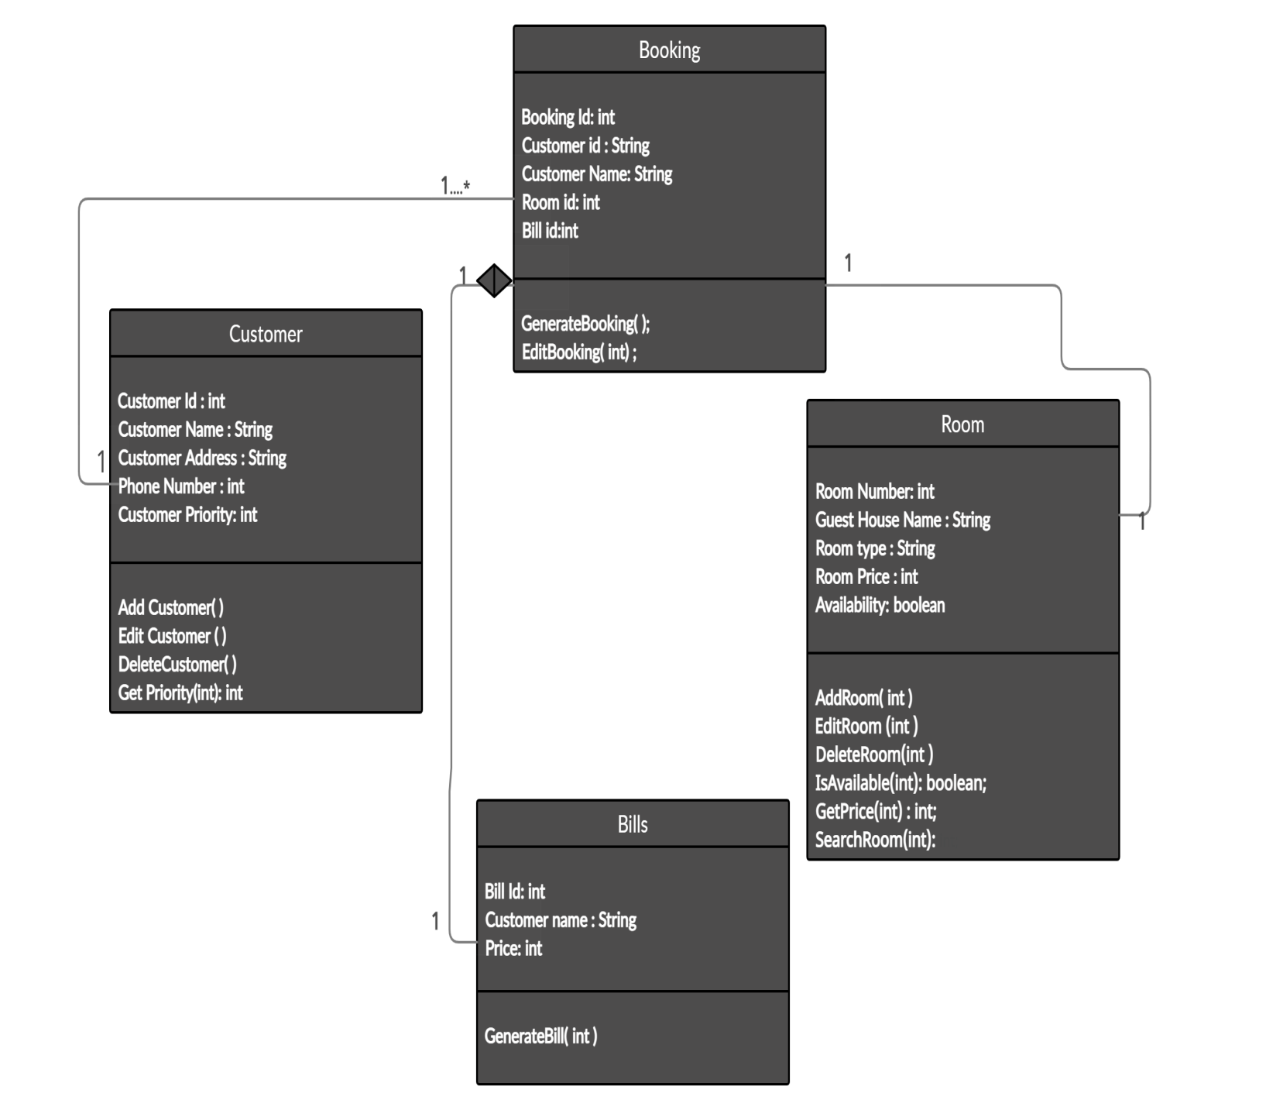

## 1.2 Responsibilities – Use Case Diagram

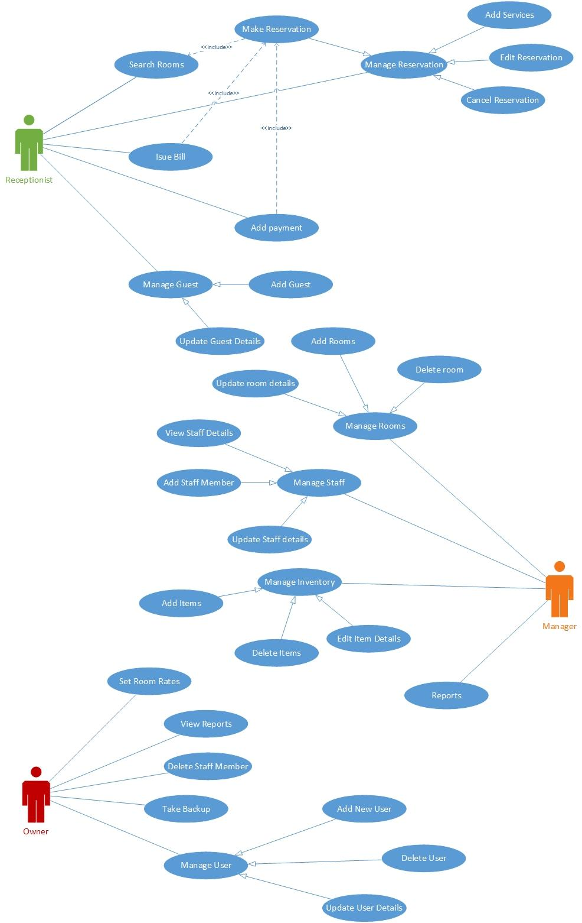

## 1.3 Static snapshot of the system - Object Diagram

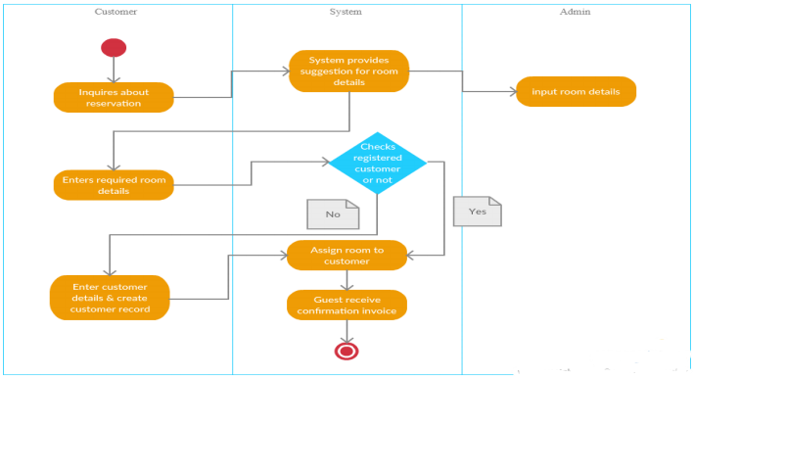

## 

## 1.4 System Interactions through Sequence Diagrams

This section includes some of the sequence diagram which depicts some interactions in our application. A sequence diagram shows, as parallel vertical lines (lifeline), different processes or objects that live simultaneously, and as horizontal arrows, the messages exchanged between them, in the order in which they occur.

### 1.4.1 Check Availability – Atul Singh

Used for checking if a room is available or not. Details of available room is retrieved from the database and displayed to user.

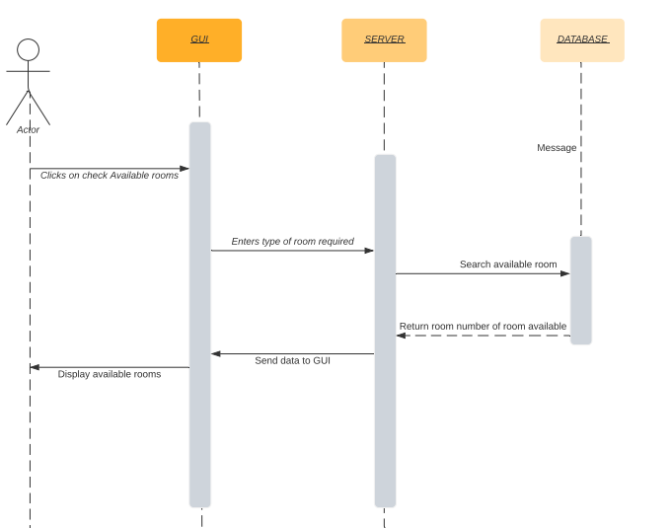

### 

### 1.4.2 Make Reservation– Aditya Jha

Add new reservation. Hotel Guest Details updated to include current Guest. Also the room status will be changed to unavailable. On successful booking user receives notifications on registered phone number.

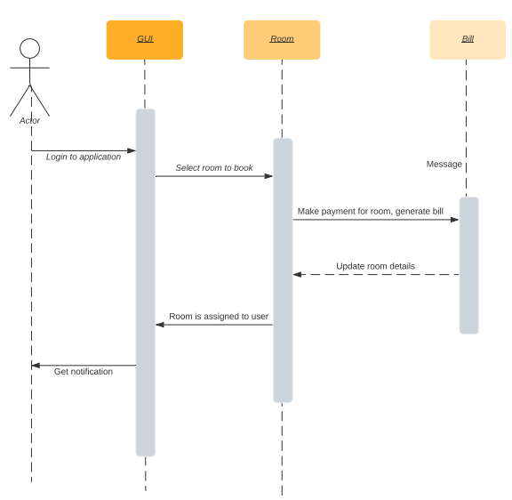

### 

### 1.4.3 Set Room Rates– Ritik Gautam

Set rates to different types of room available in guest house. Set prices according to age of guest also if required. User who has admin credentials only can perform this task. Also changes made in rates should be applied to all rooms and displayed in the application as fast as possible.

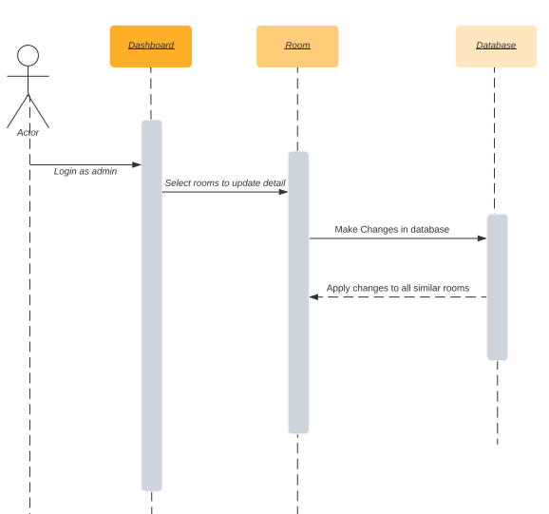

### 

### 1.4.4 Guest Search –Amit Kumar Panja

This task can only be performed by admin. Admin enters guest name or

Id and gets his details. If required he can update or delete his details from database.

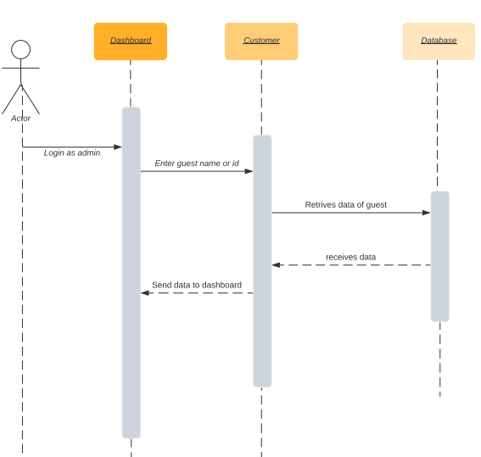

### 

### 1.4.5 Add Guest – Palash Bajpai

The new guest is added to database in customer class. This task can be performed by the receptionist if guest books room at office or user can directly use app and signup there to use the application. Users details should not be already present in the database.

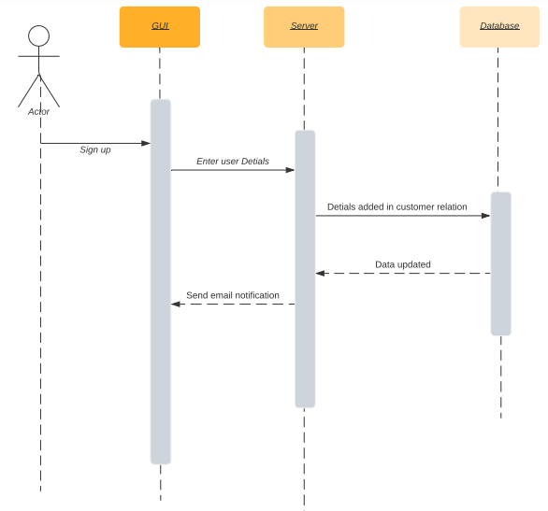

## 1.5 Control and Data Flows through Activity Diagrams

*<Short description about activity diagram>*

### 1.5.1 <Name of Activity Diagram 1> - <Team member Name>

*<Short description about activity diagram 1>*

*<Insert diagram here>*

### 1.5.2 <Name of Activity Diagram 2> - <Team member Name>

*<Short description about activity diagram 2>*

*<Insert diagram here>*

### 1.5.3 <Name of Activity Diagram 3> - <Team member Name>

*<Short description about activity diagram 3>*

*<Insert diagram here>*

### 1.5.4 <Name of Activity Diagram 4> - <Team member Name>

*<Short description about activity diagram 4>*

*<Insert diagram here>*

### 1.5.5 <Name of Activity Diagram 5> - <Team member Name>

*<Short description about activity diagram 5>*

*<Insert diagram here>*

# Database Design

## 2.1 ER Diagram

*<Insert diagram here>*

# Implementation Plans

## 3.1 Technology Stack

*<Describe the software platforms, programming languages utilized for implementing the project.>*

## 3.2 Work Estimates

|  |  |
| --- | --- |
| **Description** | **Time Estimate**  **(Hours)** |
| <Task1> | <Hours> |
| <Task2> | <Hours> |

# References

*<Use APA Style of formatting for the list of references>*

# Appendix A - Activity Log

*<Provide details of group meetings - when you met and for how long. You must also state what was the contribution (the sections mainly, then diagrams) of each of the team members. Team Lead will have complete responsibility and freedom to complete the Activity Log.>*